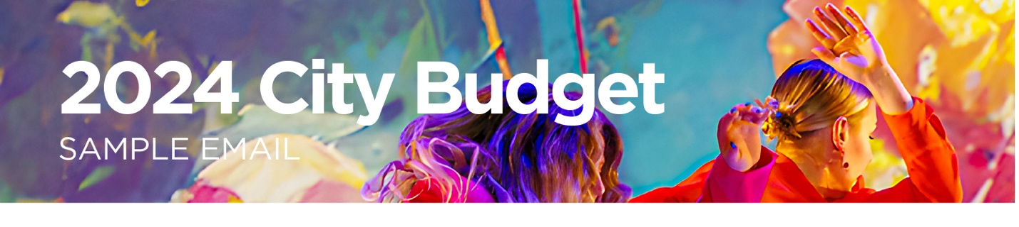
Instructions: Items highlighted and bolded require your attention before you send your email to support TAC. Thank you for supporting our work by raising your voice!
TO: Find your Councillor using this web form, and ensure you address your email to them
COPY AND PASTE THESE ADDRESSES INTO THE CC FIELD (the Mayor & Budget Committee):
councillor_carroll@toronto.ca; Councillor_Cheng@toronto.ca; councillor_mckelvie@toronto.ca; councillor_moise@toronto.ca; councillor_morley@toronto.ca; councillor_perks@toronto.ca; mayor_chow@toronto.ca
Subject: I support a $2M increase to Toronto Arts Council’s 2024 budget
Dear Councillor <<your Councillor’s Last Name>>
I am a voter in your ward writing to express my support for Toronto Arts Council’s request for a $2 million budget increase in the 2024 City Budget.
Toronto Arts Council (TAC) is a direct link between the City and its arts communities. Last year, TAC provided over 900 artists and arts organizations with funding that not only helps them to continue living and creating in Toronto, but also supports the vital role they play in making our city safer and more caring, increasing equity and inclusion, improving mental health and social cohesion across communities, and ensuring that Toronto is a vibrant place to live.
I want to express my gratitude for the City’s investments in the arts to date and thank you for preserving TAC’s budget.
However, TAC’s budget has not kept pace with inflation and we can’t afford to let the arts fall further behind. Mayor Chow’s election commitment to increase TAC’s budget by $2 million in 2024 is important – this is why I am asking you to support this increase when City Council meets to confirm the 2024 budget on February 14th.
A budget increase to TAC is an investment in Toronto’s social and economic well-being as well as the current and future strength and diversity of the arts across the city. TAC’s vital programs include supports for youth engagement, newcomer and refugee artists, opportunities for Black and Indigenous artists, and arts organizations and initiatives outside the downtown core.
<<OPTIONAL – Include a personal story or statement about what the arts means to you>>
Thank you in advance for supporting TAC’s $2 million budget increase.
Sincerely,
<<YOUR NAME>>
<<OPTIONAL – Your Contact Information / Postal Code>>

